## Niagara County

Probation Department

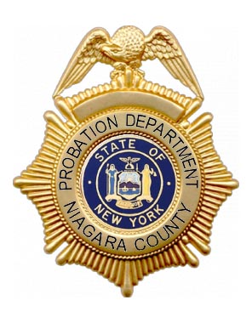

Annual Report

2023



**OVERVIEW**

Probation is an integral part of the Criminal Justice System and operates within the legal framework of the Criminal Procedure Law, the Penal Law, and the Family Court Act. It is our mission to protect the community through intervention in individual's lives by facilitating compliance with court orders and serving as a catalyst for positive change. We operate in collaboration with our criminal justice partners and the community. We provide services to the courts, help strengthen families and give victims a voice in the justice system. We provide leadership and services in a cost effective community based setting.

Probation is the largest community corrections program in the world. In New York State, there are more people under probation supervision than in prison and on parole combined.

Probation is a court-imposed sentence that, subject to stated conditions and restrictions, releases a person convicted of a crime into the community, instead of confining them to jail or prison.

**LEGAL AUTHORITY**

Probation is a mandated service. Pursuant to article 12-A, Section 256, of the Executive Law, “each County shall maintain, or provide a probation agency or agencies to perform services therein including intake, investigations, pre-sentence reports, supervision conciliation, social treatment and such other functions as are assigned to probation agencies pursuant to law.”

The primary functions of probation are protection of the community, rehabilitation of the offender and preservation of family life.

**PROBATION OFFICERS ARE PEACE OFFICERS**

A peace officer is a person who is legally designated to exercise peace officer powers while performing their assigned duties. NYS Criminal Procedure Law Section 2.10 identifies Probation Officers as peace officers. Peace officers can enforce laws, rules, regulations, and judgments or orders.

When acting pursuant to their special duties, Probation Officers may be required to exercise certain police-like powers. When duly trained and specifically authorized by the Probation Director, a Probation Officer may carry and possess a firearm on duty.

Probation provides the following services:

**INTAKE/DIVERSION**

A Family Court Law mandated process whereby the probation officer examines and evaluates the circumstances of each case and, where possible and permitted by law, attempts to resolve the problem without the necessity of formal Court action. Said process includes the informal supervision of Juvenile Delinquents (JD) and Persons in Need of Supervision (PINS) in the community. Officers assess risk, needs, and protective factors; screen for mental health concerns; engage the youth and their family in case planning; and connect youth and families with needed services.

**PRE-DISPOSITIONAL SUPERVISION**

Family Court ordered services for JD and PINS youth while a case is pending in Family Court between initial appearance in front of the judge and final disposition of the case. Probation Officers provide assessment, case planning, connection to needed services, and electronic monitoring as ordered by Court.

**INVESTIGATION**

This includes the gathering, recording, and interpretation of facts regarding the legal, personal and social history of individuals as well as assessment of risk in order to assist the Court in making an appropriate plan of disposition as well as consideration of conditions of supervision when probation supervision is imposed. The Probation Department serves the following Courts: Supreme, Family, County, City and Justice. In addition, this department, upon request, provides services to various Courts both outside of Niagara County and outside of New York State.

The Probation Department completes the following types of investigations: Criminal Pre-Sentence Investigations and Pre-Plea Investigations; Interim Probation Updates; Juvenile Delinquency and Persons In Need of Supervision Pre-Dispositional Investigations; Visitation, Custody and Adoption Home Studies. The Probation Department also conducts Certificate of Relief Investigations for criminal courts.

**SUPERVISION**

Probation services involve the supervision and guidance of a probationer in the community by a Probation Officer to assist the probationer in complying with court ordered conditions. This includes individuals sentenced to a period of supervision and those ordered to interim supervision prior to final disposition of their case. The overall goal is reducing the risk of recidivism thereby having a positive impact on reducing crime. Various case management techniques are utilized such as evidence based practices, cognitive behavioral interventions, periodic reassessment, collaborative case plans, connection to needed services, and use of electronic monitoring when ordered by Court.

**ENHANCED SUPERVISION OF SEX OFFENDERS**

Probation maintains a specialized caseload to facilitate enhanced supervision of sex offenders on probation. Probation Officers assigned to this workload receive specialized training in risk assessments designed for this population. They facilitate offender compliance with the Sex Offender Registration Act (SORA), refer offenders for clinical evaluations and approved treatment interventions, and monitor sex offender’s compliance with Court imposed conditions while they are under supervision. Supervision conditions for these offenders can include computer and Internet searches, and polygraph examinations. Officers also conduct quarterly Sex Offender Registry address verifications and manage Change of Address verification to the State Sex Offender Registry.

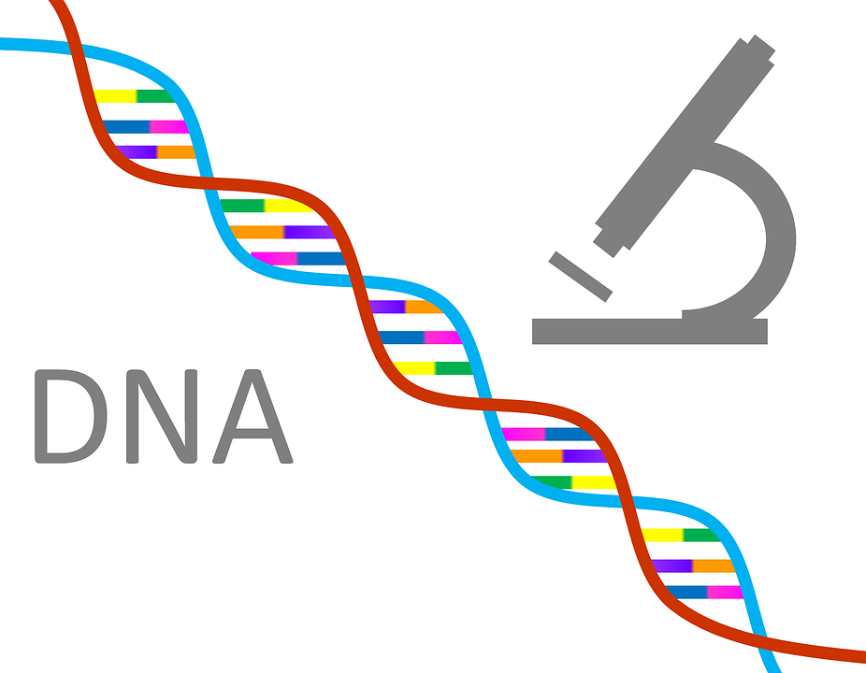

**DNA COLLECTION AND REGISTRATION**

The Probation Department has the legal responsibility to collect DNA samples from offenders sentenced to probation supervision for a DNA qualifying offense. In 2023, the NYS Division of Criminal Justice Services Office of Forensic Services processed 163 DNA sample submissions from the Niagara County Probation Department.

**TREATMENT ALTERNATIVES FOR SAFER COMMUNITIES (TASC)**

The Niagara County TASC Program is an alternative to incarceration program designed to reduce the burdens on the criminal justice system by providing eligible defendants with access to substance use treatment, among other service needs, with the aim of reducing the likelihood of recidivism and enhancing public safety. The TASC Program has two main components: Traditional TASC programming and Alternatives to Jail Detention (AJD) pre-trial services. Traditional TASC services Niagara County residents with felony offenses/convictions who have substance use problems and for whom an alternative to incarceration plan is appropriate. The TASC Program supplements probation supervision and treatment court programs by providing enhanced case management services to individuals with high need substance use/behavioral health concerns. The AJD Program provides pretrial release services for the county.



**Pretrial Release Services**

Criminal Justice Reform legislation enacted in 2020 requires counties to provide pretrial release services for individuals charged with a crime. The Probation Department is Niagara County’s designated agency for providing these services. Probation Officers and Treatment Alternatives for Safer Communities (TASC) Case Managers work with individuals in the community while their cases are pending in Criminal Court. Pretrial staff encourage the individual’s appearance in Court and monitor any conditions of release imposed by the Court. Services include, but are not limited to, assessment for risk of failure to appear at court, reminders of court dates, case planning, linkage to needed services, updates to the Court regarding progress/compliance with conditions of release, notifications to Court of any non-compliance with release conditions including any additional arrests or charges incurred by the individual. The department also utilizes electronic monitoring of these individuals as ordered by the Court as part of their conditions of release.

**SPECIALIZED SERVICES**

**IGNITION INTERLOCK DEVICE COMPLIANCE MONITORING**

Niagara County Probation is Niagara County’s monitoring agency for individuals required to comply with New York State’s Leandra’s Law. Generally, the law requires individuals convicted of certain drinking and driving offenses to have an Ignition Interlock Device (IID) installed on any vehicle they own or operate for a specific period of time. Probation works with the NYS Department of Motor Vehicles, IID vendors, IID installation sites, and law enforcement partners to monitor compliance of people sentenced to Probation and those sentenced to a Conditional Discharge, who are required to have an IID installed.

**Gun Involved Violence Elimination (GIVE) Initiative**

The Probation Department partners with the Niagara Falls Police Department, the Niagara County Sheriff’s Office, and the Niagara County District Attorney’s Office on this initiative to help control gun violence in Niagara Falls, NY. The partnership involves administrative level cooperation between agencies to implement evidence-based strategies designed to impact gun violence. Implementation of the strategies involves interagency cooperation on the front lines to share field intelligence, coordinate and carry out operations, and track outcomes.

**EMPLOYMENT FOCUSED SERVICES (EFS) PROGAM**

This program is a partnership between the Probation Department and Niagara County Employment and Training. The program focuses on Medium to High-Risk individuals with high employment needs, those who are able work but are unemployed or under-employed. Participants complete a Cognitive Behavioral Intervention proven to reduce recidivism, complete an employment readiness class - Ready, Set, Work!, and work with an Employment Counselor to develop job search and interview skills, to procure gainful employment, and use what they have learned through their participation in the program to maintain employment.

**JUVENILE RISK INTERVENTION SERVICES COORDINATION (JRISC)**

This program involves the use of established research-supported interventions that target the high risk and need factors among Juvenile Delinquent (JD) and Persons In Need of Supervision (PINS) youth involved with the department. The Probation Department works collaboratively with Community Missions of Niagara Frontier, Inc. to provide the Family Solutions Program (FSP) and with Catholic Charities to provide Multi-Systemic Therapy (MST) to qualifying youth and families. These evidence-based programs work to change the youth’s negative behaviors while keeping them within the community, and with their family, negating the need for placement outside of the youth’s home.

**E-CONNECT**

The E-Connect project was initiated as a response to above average juvenile suicide rates in Niagara County. The project is a partnership including the Probation Department, Niagara County Department of Mental Health and Substance Abuse Services, and Monsignor Carr Clinic, along with Columbia University. Each youth receiving intake services from the Probation Department completes the GAIN-SS instrument, which measures potential indicators for suicide risk. Youth that score as high risk are connected to Crisis Services staff immediately for assessment of the need for hospitalization, assisting with transport of the youth to the hospital if warranted. Those at moderate risk are scheduled for an appointment with a mental health counselor within 72 hours of the initial screening. Youth at low risk of suicide are connected to a mental health service provider for further assessment of any service need, and linkage to needed services as appropriate.



**NIAGARA COUNTY REENTRY TASK FORCE (CRTF)**

This initiative is a multi-agency task force to coordinate services for offenders transitioning from prison back into the community in Niagara County. This program seeks to reduce recidivism and increase public safety through improved coordination and collaboration among criminal justice, social services, educational, health and mental health systems. The Probation Department manages a grant through NYS Office of Probation and Correctional Alternatives for the CRTF program. Probation contracts with Community Missions of Niagara Frontier, Inc., to provide case management services for program participants. The Probation Director and the Reentry Services Manager from NYS Department of Community Corrections are co-chairs for this program.

***2023 CRIMINAL COURT UNIT STATISTICS***

Differential Classification of Offenders under Supervision as of December 2023

|  |  |
| --- | --- |
| Low Risk | 559 |
| Medium Risk | 198 |
| High Risk | 74 |
| Greatest Risk | 60 |

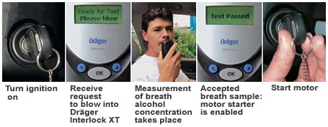

Ignition Interlock – Conditional Discharge Monitoring

|  |  |
| --- | --- |
| IID – CD Monitoring Caseload | 147 |

## ***2023 FAMILY COURT STATISTICS***

Pre-Dispositional Supervision

|  |  |
| --- | --- |
| PDS Cases Open as of December 2023 | 41 |

Formal Supervision Cases as of December 2023

|  |  |  |
| --- | --- | --- |
| PINS |  | 0 |
| JD |  | 12 |
| Other Adult |  | 42 |

|  |  |
| --- | --- |
| TOTAL | **54** |

***TASC UNIT STATISTICS***

Traditional TASC

|  |  |
| --- | --- |
| Screenings | 145 |
| Intakes | 137 |

Alternatives to Jail Detention (AJD) Program

|  |  |
| --- | --- |
| Intakes | 193 |
| Monitor/Supervise | 193 |
| CBI Enrollment | 68 |

Niagara Falls PreTrial Services

|  |  |
| --- | --- |
| Intakes | 236 |
| Monitor /Supervise | 236 |



## ***COLLECTIONS***

## Pursuant to the law, the Probation Department is authorized to collect monies including surcharges, fees, fines and restitution. Said monies are disbursed to various sources including crime victims, County of Niagara (revenue), and other government agencies.

## The totals for 2023 are:

|  |  |  |  |
| --- | --- | --- | --- |
| Restitution |  |  | $85,803.48 |
| Fines |  |  | $57,893.27 |
| Fees  (County revenue) | Supervision Fees | $157,702.61 |  |
|  | Drug Test Fees | $1,123.00 |  |
|  | Electronic Monitoring Fees | $509.00 |  |
|  | Restitution Surcharge | $8,665.80 |  |
|  | Total County Revenue | | $168,000.41 |
|  | **Total Collections** | | **$311,697.16** |

**PROBATION STAFFING**

The Niagara County Probation Department has the following positions:

|  |  |
| --- | --- |
| Probation Director | 1 |
| Deputy Probation Director | 1 |
| Probation Supervisor | 5 |
| Supervising Social Worker - TASC | 1 |
| Probation Officers | 27 |
| Probation Officer-Community Liaison | 1 |
| TASC Case Manager | 4 |
| Account Clerical II | 2 |
| Clerical II | 4 |
| Clerical II – TASC | 1 |
| Clerical I | 2 |
| Clerical PT - TASC | 1 |
| Total Personnel | 50 |

**CONTACT INFORMATION**

Deborah M. LaRock, Probation Director

716-438-4061

[deborah.larock@niagaracounty.com](mailto:deborah.larock@niagaracounty.com)

Jeffrey Sheehan, Deputy Probation Director

716-278-8240

[jeffrey.sheehan@niagaracounty.com](mailto:jeffrey.sheehan@niagaracounty.com)

Angela Beightol, TASC Supervisor Amanda Bond, Probation Supervisor

TASC Unit/Pretrial Release Services Niagara Falls Criminal Court Unit

716-439-3381 716-278-8122

[angela.beightol@niagaracounty.com](mailto:angela.beightol@niagaracounty.com) [amanda.bond@niagaracounty.com](mailto:amanda.bond@niagaracounty.com)

William E. Collins, Probation Supervisor Jennifer Drake, Probation Supervisor

Lockport Criminal Court Unit Niagara Falls Family Court Unit

716-438-4055 716-278-8122

[william.collins@niagaracounty.com](mailto:william.collins@niagaracounty.com) [jennifer.drake@niagaracounty.com](mailto:jennifer.drake@niagaracounty.com)

Jerome Sperrazza, Probation Supervisor Susan Woock, Probation Supervisor

Niagara Falls Criminal Court Unit NT Criminal/NT & Lockport Family Court

716-278-8122 716-743-4526

[jerome.sperrazza@niagaracounty.com](mailto:jerome.sperrazza@niagaracounty.com) [susan.woock@niagaracounty.com](mailto:susan.woock@niagaracounty.com)